Jomon Pottery

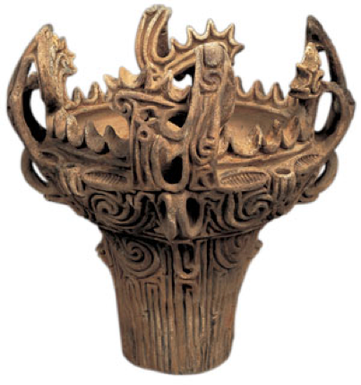

Jomon earthenware deep pot, made between 3000 and 2000 BC. The rough-and-ready energy of an ancient culture lives on in the fanciful design of this pot. Archeological find from Niigata Prefecture. Height: 32.5 cm. Property of Tokyo National Museum.

A history of the development of Japanese Ceramics
Earthenware was first made on the Japanese archipelago about 13,000 years ago. That is before anywhere else in the world, as far as we know today. Large, deep pots used for boiling were the most common. The clay was decorated by rolling or pressing braided cord onto the surface. Because of these cord patterns, earthenware from this time is called jomon doki (jo = cord; mon = pattern, doki = earthenware). About 5,000 years ago, during the Jomon period, some remarkably dynamic designs emerged, including billowing wave ornamentation for pot rims and fanciful patterns covering every part of the exterior.
Source: http://web-japan.org/nipponia/nipponia32/en/feature/feature01.html

Short Answer Question 1: Using the information and image above; answer all parts of the question below.
A. Using the information given, identify at least 3 facts that would be of interest to historians of the Paleolithic period.

B. Using your knowledge of paleolithic people, why are these artifacts unusual for the paleolithic period?

C. In what way do these artifacts show evidence that paleolithic people developed sophisticated technologies and adapted to different geographical environments?

